



CONFIDENTIAL

Any disclosure, reproduction, distribution or other use of this document by an individual or entity other than the intended recipient is prohibited

****team

|  |  |
| --- | --- |
| https://home.miskre.org/assets/img/ec.jpg | Peter Nguyen – Executive Chairman  Peter Nguyen is the world’s foremost authority in direct-to-consumer digital advertising. Peter has created dozens of multi-million dollar Internet brands and is the creator of Accelerated Ventures, which is now being taught at the 2nd-ranked entrepreneurship program in the US.  Founder and CEO of Ad Exchange Group, which is the leading direct-to-consumer digital performance-based agency in the nation. Ad Exchange Group services leading brands like Jeunesse, Bulletproof, Dollar Beard Club, Feel Rich, Cosmoderm, Pathway Genomics, and many more. |
|  | Doan Tran – Operations Manager  Doan is a self-made entrepreneur and has experience managing several startups taking them from 0 to 8 figures a year. He has been interested in the economics of cryptocurrencies since 2014, and is passionately working towards a future where cryptocurrencies are used globally for daily transactions. |
|  | Cuong Le – Data Scientist / Blockchain Researcher  Cuong was first promoted to Associate Professor in 2012, at top universities like Ton Duc Thang University and Vietnam National University.  He is an active researcher in the fields of artificial intelligence, knowledge discovery, and data mining. He has publicized works in many international journals as well as proceedings at international conferences. He has been actively researching blockchain technology in the past several years and is successfully applying his previous research to improving blockchain ecosystem. |
|  | Darren Lopes – Executive Advisor / Strategist  Darren is master in online business and marketing strategies. Being extremely influential in the social media space has given him the ability to take startups from 0 to 6 figures revenues within the first day of launching. He has special talent in positioning brands to flourish.  Prior to focusing on ecommerce, Darren was involved in multiple media websites and with his strategies they reached top 200 in the world within the first few months. Now in this crypto era, he's been focused on taking all his learnings of online business and applying it to a decentralized world where there is no boundaries. |
|  | Jay Croft – Community Manager  Jay is a serial internet entrepreneur, world traveler, and photographer. Having developed a passion for entrepreneurship at a very young age, Jay has always been fascinated by social media and the marketing power it harnesses.  Jay has built several e-commerce brands from the ground up, traveled the globe through brand partnerships, competed as a quarterback on the NCAA level, and is passionate about how a decentralized world will shape our future. He is dedicated to leaving this place better than he found it - empowering and inspiring one day at a time. |
|  | Nhu Tran – Community Manager  Nhu has always been passionate about the ideas of liberty and freedom, which make her a wonderful addition to our project. Nhu have a unique background which will no doubt add interesting flavor to our project having been a model, DJ, artist manager, and catwalk director. She have experience in managing and working with large groups of people to ensure proper proceedings of many shows and large events. |
|  | Gia Nguyen – Creative Director  Gia is a super designer and senior front-end engineer. He enjoy turning complex problems into simple, beautiful and intuitive interface designs. He also has experience in building high performance multi-platform applications and ecommerce networks. |
|  | Huy Tran – Blockchain Engineer  Huy's specialty is information security, and machine learning. He played a pivotal role in the development of many currency exchange, money remittance, prepaid card issuance/loading, and foreign exchange platforms for the Asian market. He has been researching blockchain since 2013 and believes that blockchain will be the future of money. |
|  | Thuan Tran – Blockchain Engineer  Thuan is a software engineer, with strong understanding of blockchain technologies and architecture. He has been researching blockchain since 2013, and been part of the development team for many cryptocurrency exchanges as well as payment gateway systems. |



miskre is a decentralized currency with no central power. miskre aims to build a global ecosystem that empowers entrepreneurs to bring new technologies to market, and bring monetary freedom to the masses. Allowing everyone; no matter who they are, where they live, or their financial status to participate in the global economy with full authority and freedom.



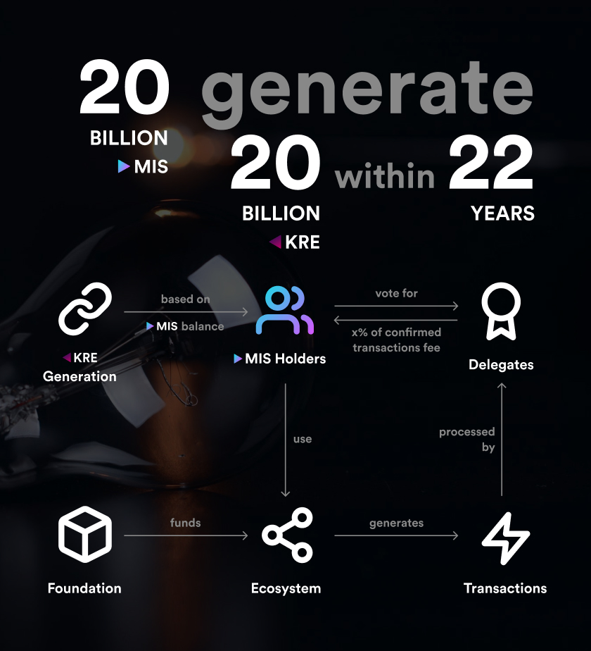

# Why we will come out on top:

## miskre Labs



At our labs, we can incubate startups for as cheap as 50k a year per team. We would be able to create many online services to help boost the miskre ecosystem. This will create huge value for our token holders once we have many businesses thriving using our token.

## miskre Pay



|  |  |  |
| --- | --- | --- |
|  |  |  |

This alone can be its own ICO with today’s standard. Most ICOs today are not setup to last well into the future, with some even going backwards in technology with crypto credit cards. miskre Pay thinks ahead in terms of technology. Our wallet app will allow users to easily send and receive cryptocurrencies, as easy as WeChat and AliPay does it for FIAT. Users will be able to use miskre Pay to call a cab, pay bills, use subscription services, etc.

## miskre Exchange

Many cryptocurrencies run into the problem of having no way to go directly from FIAT to their token, and having to go through intermediaries like BTC and ETH. We will solve that by building our own exchange and enabling USD/MIS USD/KRE. miskre Exchange will also serve as a payment gateway for online services.

### Incentivized Delegates System

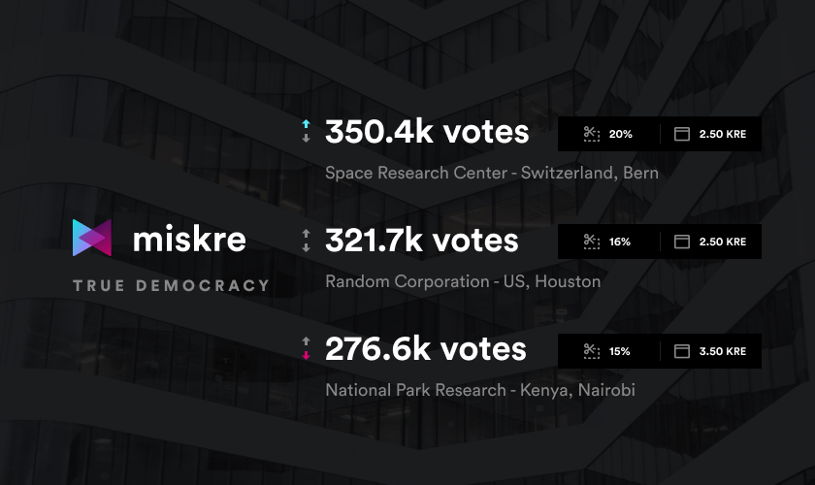

We have an incentivized opt-in government system that is truly democratic. Users are incentivized to participate in order to receive rewards from delegates. With our system we ensure that our blockchain is constantly being updated and prevents manipulation.

### Truly Decentralized Blockchain

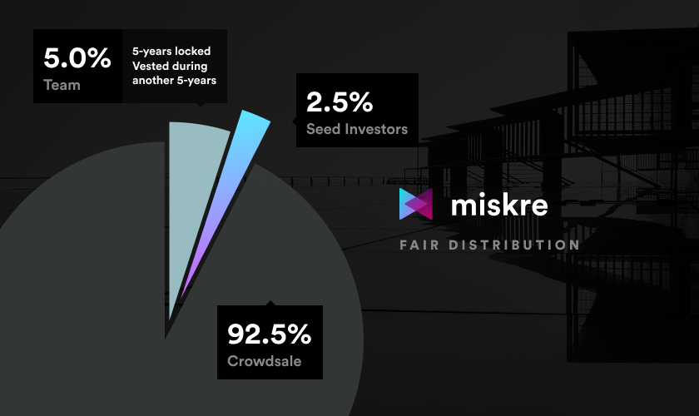

You can’t go backward in blockchain, so you have to start correct. We believe with our structure, it set us up to win in the long term and come out on top. The end goal is to be the only chain left standing. If it is completely decentralized and fair, why would you need two different blockchains?

We are a team that truly understands marketing and social media coupled with an amazing idea, once probably funded, we have no doubt we will break records in terms of money raised; giving our tokens high marketcaps, benefiting the investors and early adopters.